
Signature Verification System

Mohanad ezzat
2023-08326

Signature Verification System Documentation

1. Project Title
Signature Verification System Using Image Processing and Feature Extraction

2. Project Overview
This project implements an offline handwritten signature verification system using image processing techniques and pattern recognition. The system compares a stored (original) signature with a user-provided signature image to determine whether they belong to the same person.
The verification process relies on:
- Image preprocessing (grayscale, binarization, noise removal)
- Structural Similarity Index (SSIM)
- Shape-based feature extraction (area, perimeter, Hu moments)
The final decision is based on a combination of similarity score and feature distance.

3. Objectives
- Load and store original signatures for trusted users
- Load and store new signatures and compare them with original signatures by name
- Preprocess signature images to remove noise and normalize them
- Compare signatures using SSIM for visual similarity
- Extract geometric features for shape-based verification
- Provide a final verification decision (Match / Not Match)

4. Technologies and Libraries Used
- Python 3
- OpenCV (cv2) – image processing
- NumPy – numerical computations
- Matplotlib – image visualization
- scikit-image (SSIM) – structural similarity measurement
- OS module – file handling
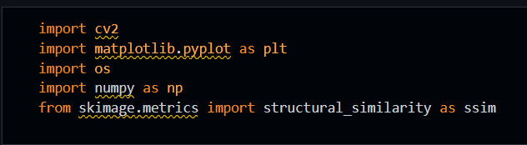

5. Project Folder Structure
/content/
│── Signatures/
│ ├── Mohanad.png
│ ├── Ali.png
│
│── Users/
│ ├── Mohanad.png
│ ├── Ali.png
│
│── signature_verification.py
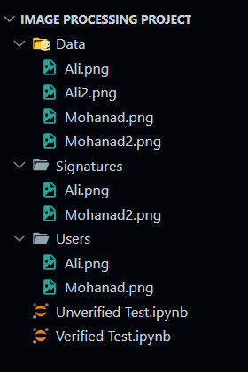

6. System Workflow
- Load stored original signatures
- Ask user for the signature name
- Preprocess original signature
- Load and preprocess user signature
- Resize user signature to match original
- Compare signatures using SSIM
- Perform feature-based comparison
- Make final verification decision

7. Detailed Code Explanation

7.1 Loading Signatures
Original signatures are loaded in grayscale mode and stored in a dictionary for easy access.
Input: PNG signature images
Output: Dictionary of grayscale signature images

7.2 Utility Functions

Display Function
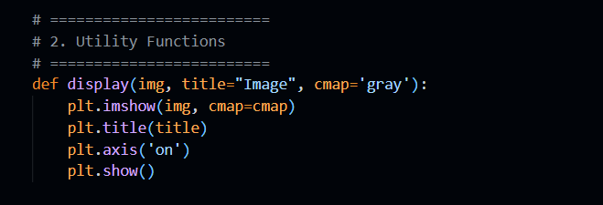

Grayscale Conversion
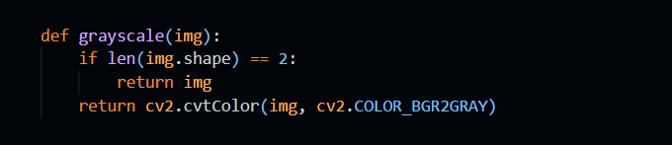

Binarization

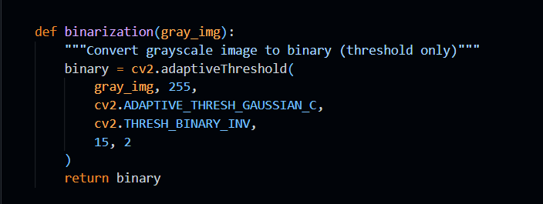

Preprocessing (Noise Removal)
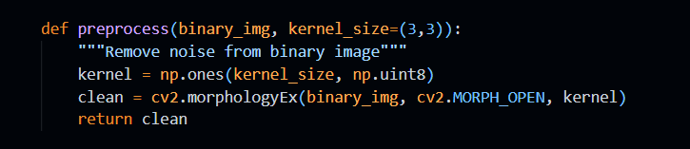

Resizing
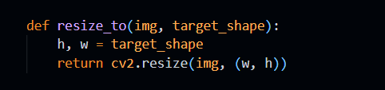

7.3 Feature Extraction
The system extracts shape-based features:
- Contour area
- Contour perimeter
- - Hu Moments (7 invariant moments)
These features are combined into a single feature vector representing the signature shape.
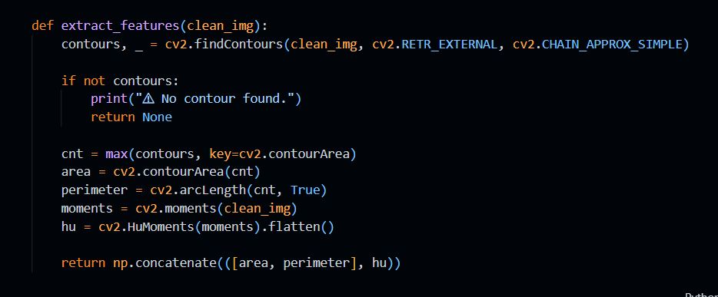

8. Signature Preprocessing Steps
For both original and user signatures:
  - Displaying the original signature
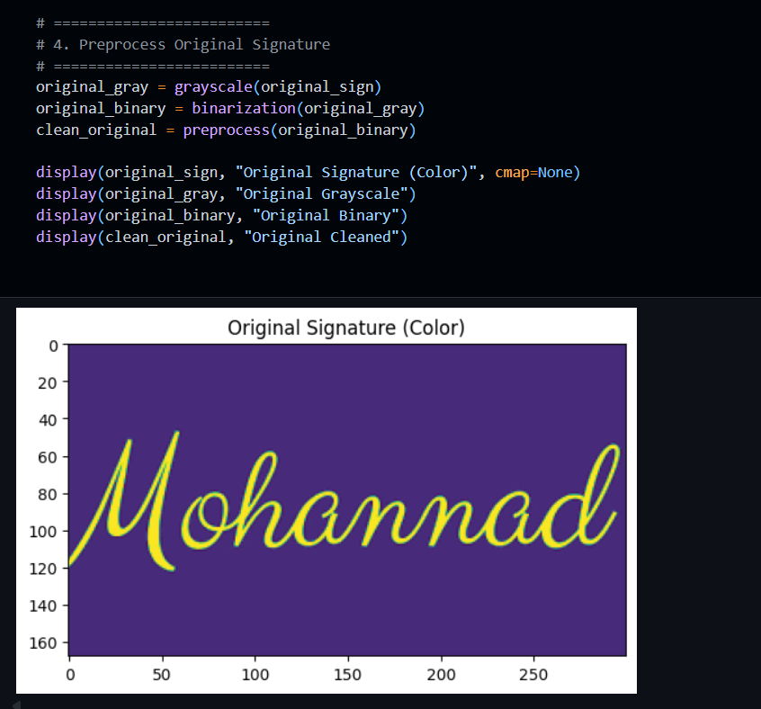
  - Grayscale conversion
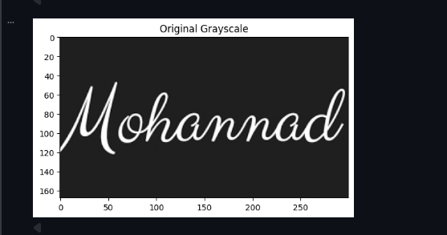
  - Adaptive thresholding (binary image)
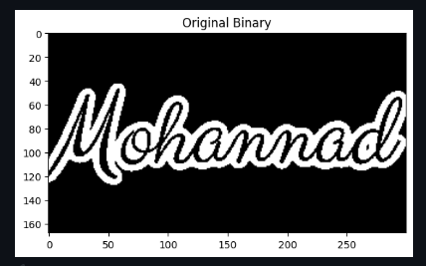
  - Morphological noise removal
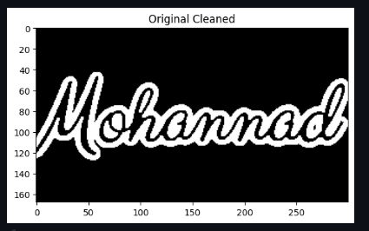
  - Image resizing (For User Signature to be compared with the original)
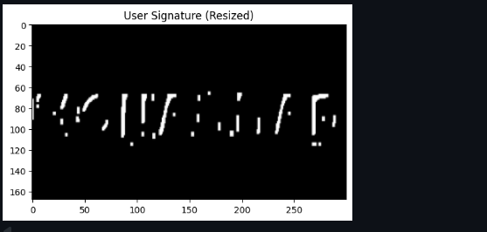

9. Signature Comparison Techniques

9.1 SSIM (Structural Similarity Index)
SSIM measures the visual similarity between two images.
Score Range: 0 to 1
- 1.0 → Identical images
- 0.75 → Acceptable similarity
- Otherwise → Unacceptable similarity
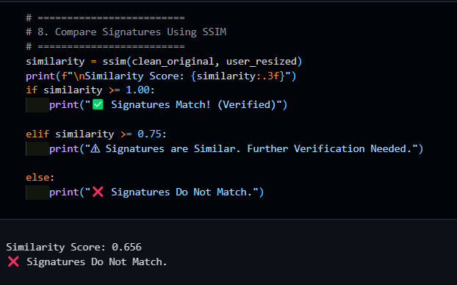

9.2 Feature-Based Comparison
The Euclidean distance between feature vectors is computed.
- Small distance → Similar shape
- Large distance → Different signatures
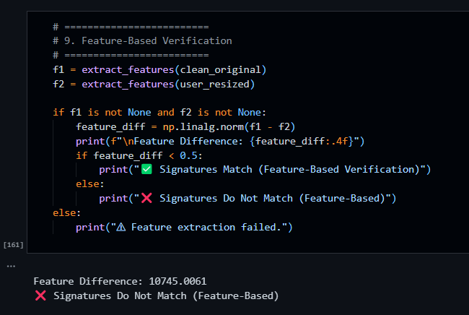

10. Decision Rules
Condition | Result
SSIM > 0.75 and Feature Diff < 0.5 | Verified (Match)
Only SSIM valid | Partial Match
Only Features valid | Partial Match
Neither valid | Not Verified

11. Outputs

Numerical Outputs
- SSIM similarity score
- Feature difference value

Visual Outputs
- Original signature (grayscale, binary, cleaned)
- User signature (grayscale, binary, cleaned, resized)

Final Output Message
- Signature Verified
- Partial Match
- Signature Does Not Match
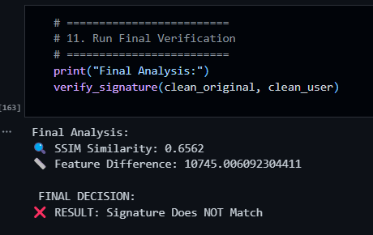

12. Final Verification Function
The verify_signature() function performs an end-to-end verification using both SSIM and feature-based analysis and prints a final decision.
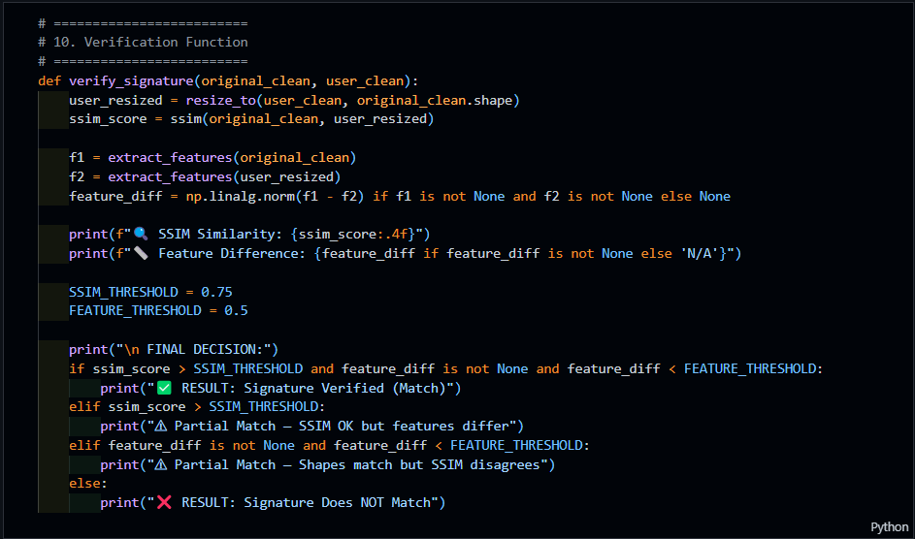

13. Conclusion
This project demonstrates a practical signature verification system using classical image processing techniques. By combining visual similarity (SSIM) with geometric features, the system achieves reliable verification results while remaining computationally simple and interpretable.

